**Managing Director,**

**ASO Savings,**

**FMBN House, Central Business District**

**Abuja**

Dear Sir,

**PROPOSAL FOR WEB AND MOBILE APPLICATION DEVELOPMENT FOR REAL ESTATE**

Connexxion Telecom and Solutions a leading ICT company with vast expertise in web presence software solutions to deploy a MOBILE APP AND WEB APPLICATION for ASO SAVINGS. We develop and deploy Software projects to multiple business sectors to suit their needs.

Our approach is to capture our client’s business requirements and develop various customized software to meet their business needs.

The solutions/features being proposed includes but not limited to the following:

* **BUY MODULE**
* **SELL/RENT**
* **CONTENT CREATION/MANAGEMENT**
* **ADMINISTRATIVE MANAGENT**
* **FINANCIAL MANAGEMENT**
* **HOME SERVICE PROVIDERS**
* **ADVERTISING MANAGEMENT**

This solution when deployed, unlike face-to-face or phone-only transactions where things talked about may be forgotten or missed out, discussions using online channel provides a better way to record the conversations.

Web app provides a better venue for you and your clients to talk securely about your transaction.

Please find attached detailed document explaining this solution and its benefit.

We look forward to hearing from you.

Kind regards,

**For: Lauretta Chinenye**

**Head, Business Development**

**Connexxion Telecom and Solutions Ltd**

**Introduction**

Connexxion Telecom is an IT company which develops Software projects. We have provided software solutions in the past 20years to multiple business sectors to suite their needs.

We have a global presence in USA, UK, and are strongly rooted in Africa. We have over the years provided tailored IT solution

Our approach is to capture our client’s business requirements and develop various customized software to meet their business needs.

**Our proposed solution**

For Aso Savings, Connexxion Telecom is proposing a real time Real Estate solution for your organization, which includes a web and mobile app.



Our solution will ensure that these features are well designed -

**Advanced Search Options**

An advanced search form is the spine of every good real estate listing website. This will enable users to search listings in different ways, and makes searches simple and fast. Its a smooth way to search by location, price, type, etc

**Beautiful Image Gallery**

An image is worth a thousand words. So, if you want to attract users’ attention and tell an interesting story, the one that will put you above the average, beautiful image gallery is all you need.

Images make the most impactful content on a real estate website as it affects impressions for a potential buyer.

**Contact forms**

After getting users interested in listings and properties on your website? Then this feature to [easily contact you](https://epitrove.com/item/wisdm-product-enquiry-pro-plugin-for-woocommerce/) and ask questions or discuss details is the deal.

**Mobile Responsiveness**

Our solution will also ensure that the mobile app and website is mobile-responsive, so your company will not lag behind in the trend or miss out on a big market share.

**Great design**

We will provide a responsive and visually pleasing website and app.

The website design will be a flawless user experience which ensures that users can easily navigate the website and find all they need. Also, it’s crucial for the website to be responsive which will be part of what we will work on. The absence of this feature will be a disappointment both for users and for search engines

**Testimonials**

Another tool to market your real estate brand is to collect testimonials.

We will ensure a testimonial tool so that testimonials from home buyers and sellers will give new clients a heads up. Both written and video testimonials can be used to prove credibility.

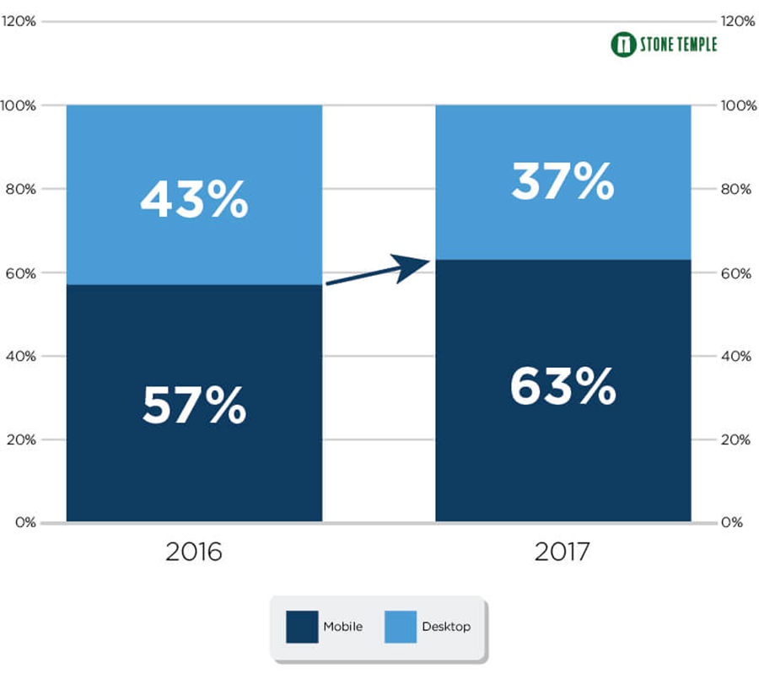

**Great Features of our MOBILE APP**

* **User Onboarding (Signup/Login)** - User onboarding is the most basic feature of a real estate app, and it has to be as simple as possible. There are three ways to do this , Social media authorization, Authorization via email and Phone verification. This will provide convenience and flexibility to the users, and make the sign-up process even simpler.
* **Listings and Database** - The property listing is another feature of the real estate app. You have to show the list of available properties with all the necessary details in the listings. Users who want to rent or sell their property should be able to add their listing without any difficulty.

A robust database is what we will deliver.

* **Maps** - You can’t just imagine a real estate app without this feature. We will Integrate maps in the app to help you provide loads of valuable information to end-users.
* **Filters and Categories -** To simplify the property searching process, we will provide advanced search options to users. We will add categories and filters so that users can easily locate properties that suit their needs.
* **Payments -** An integrated payment system is another key feature of this real estate platform. We will integrate your existing accounts with paystack, remitta, PayPal, Braintree, or Stripe.

### Content Management - This is a great tool for generating traffic from social media and search engines. There are lots of topics you can focus on in your blog: Advice on buying and selling homes, Home improvements, Local information, Real estate education, Real estate news and insights etc

* **Price calculator** - A calculator will be added to your mobile app to help users find out the final price of a home including loan interest in different banks. The calculator will be detailed, allowing users to choose the price of a home, their initial payment, the loan interest and the loan repayment period.

**OUR JOBS**

Here is access to some of our unique software we have developed and running.

**CNX 247 ERP SOFT WARE** –ENTERPRISE RESOURCE PLANNING

[www.asosavings.cnx247.com](http://www.asosavings.cnx247.com)

Login id – [info@asosavings.com](mailto:info@asosavings.com)

Password – password123

**CNX IHUMANE** – HUMAN RESOURCE MANAGEMENT SOFTWARE

[www.asosavings.ihumane.net](http://www.asosavings.ihumane.net)

Login id – administrator

Password – password1234

**Payment Terms**

**Our Costing include**

**1. Software architecture- N700,000**

**2. Software development- N5, 800,000**

**3. Software technology language -N700,000**

**4. Software development project management- N500,000**

SUB TOTAL = N7,700,000

Then TAX 7.5% = 577,500

TOTAL = 8,277,500

Also attached is our invoice raised.

**NB** – FOR TAX PAYMENT CLIAMS, WE WILL BE NEEDING YOUR TAX NUMBER FOR OUR AUDITING PROCESS WITH FIRS.

**Warranty & Limitation of Liability**

We provide a 100 days warranty, from the date of acceptance of our software proposal. During this time, if the software malfunctions, or doesn’t operate in any way, then we take the necessary steps to fix the issue and ensure that the Software operates according to the specifications. However, our services remain at your disposal for any future assistances.

**Contact us**

**You can contact us with any of the following:**

**+234 704 356 9338**

**+234 901 640 0000**

**enquiry@connexxiontelecom.com**

**info@connexxiontelecom.com**

[**www.connexxiongroup.com**](http://www.connexxiongroup.com/)

We look forward to hearing from you.

Regards,

**For: Lauretta *Chinenye***

**Head, Business Development.**

**Connexxion Telecom & Solutions.**